Contents

1. Prerequisite 2

2. Fetch Workflow XCSRF Token 3

3. Submit Workflow Instance 4

4. Retrieve Workflow Task Instances 5

5. Retrieve Workflow Context from Workflow Task 6

6. Add Task Completions Buttons 7

# Prerequisite

Following code samples are created using Business Application Studio, to execute them successfully complete prerequisite

* Add Dependency to the Workflow Service Instance in the resources section of your mta.yaml file

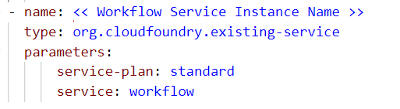

<<Workflow Service Instance Name>> is the workflow service instance name created in the cockpit

* Add Dependency to the Workflow service under the requires section of the application router module

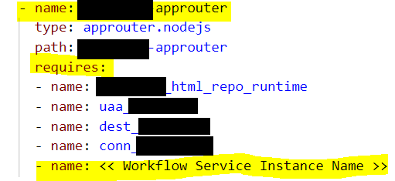

* Add Dependency in routes section in xs-app.json

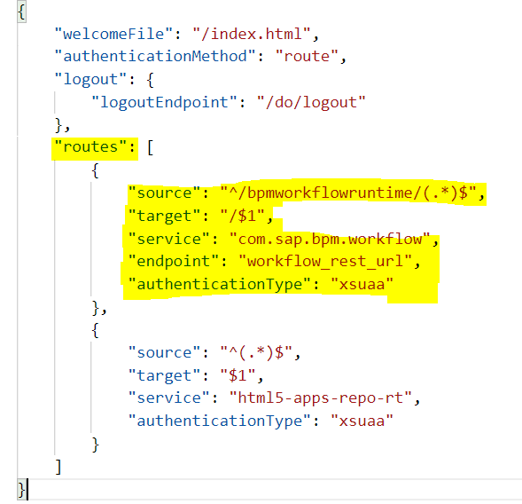

# Fetch Workflow XCSRF Token

To Call any Workflow REST API’s we need to supply XCSRF Token, below function will supply the token

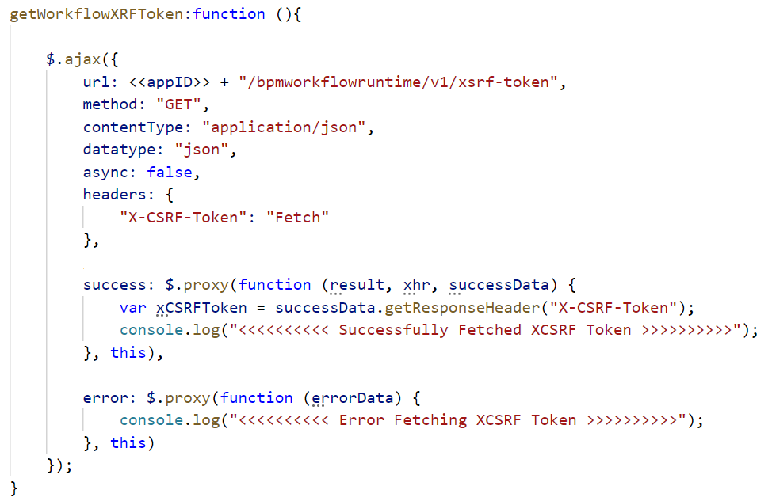

<<appID>>: This is the value of the id in the sap.app section of the manifest.json file. Remove each period from the value of id. For example, the <<appID>> value for "id":"demo.sap.com " is demosapcom.

# Submit Workflow Instance

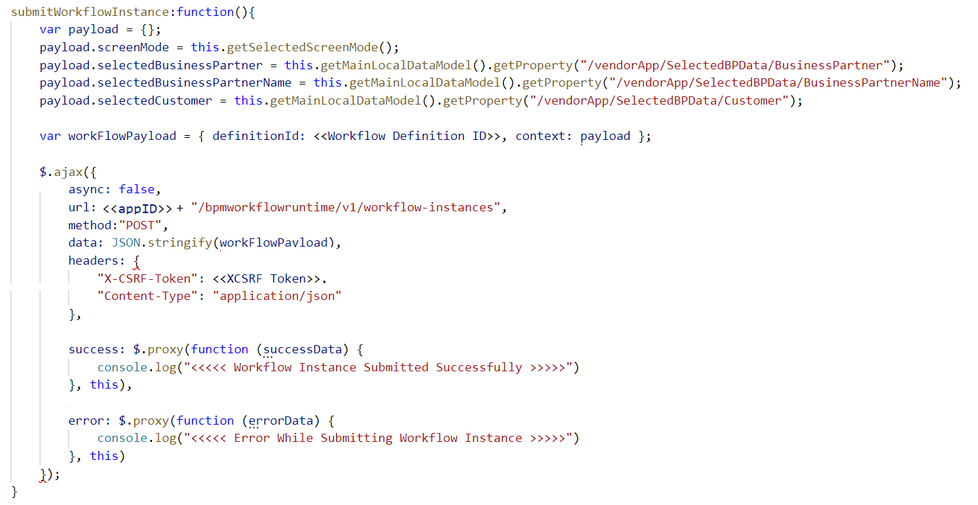

For <<appID>>, refer to section (Fetch Workflow XCSRF Token)

<<XCSRF Token>>: We can Get XCSRF Token, by executing code in section (Fetch Workflow XCSRF Token)

Substitute <<Workflow Definition ID>> with ID of the deployed Workflow

For more information, please refer to below link

https://api.sap.com/api/SAP_CP_Workflow_CF/resource

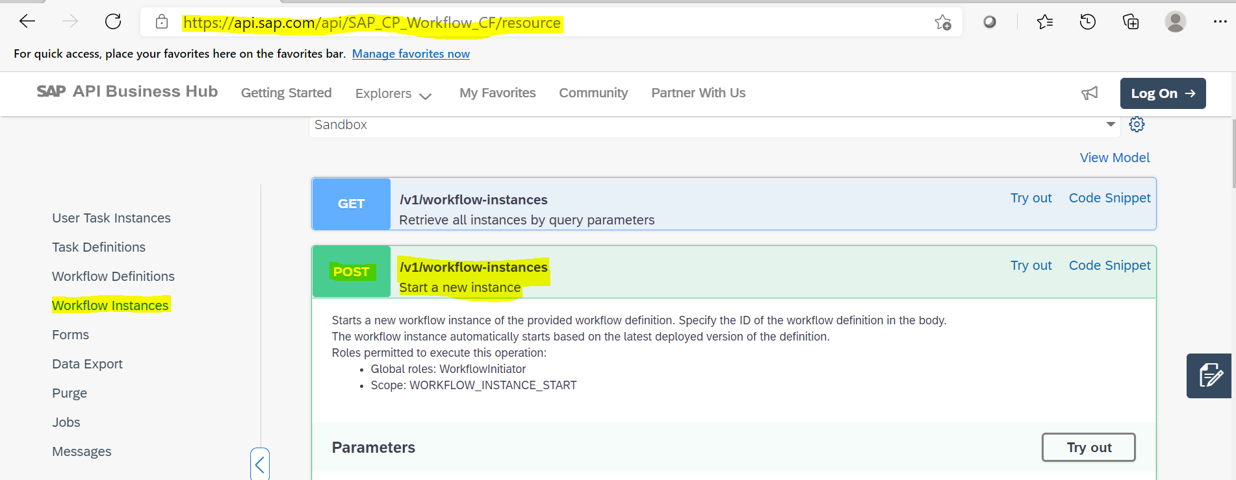

# Retrieve Workflow Task Instances

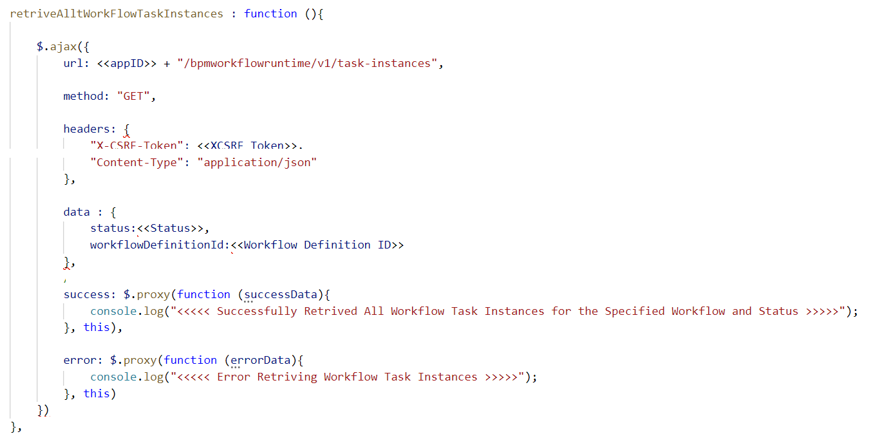

For <<appID>>, refer to section (Fetch Workflow XCSRF Token)

<<XCSRF Token>>: We can Get XCSRF Token, by executing code in section (Fetch Workflow XCSRF Token)

Substitute <<Workflow Definition ID>> with ID of the deployed Workflow

<< Status>>: Available Values for Status (READY, RESERVED, COMPLETED, CANCELED)

For more information, please refer to below link

https://api.sap.com/api/SAP_CP_Workflow_CF/resource

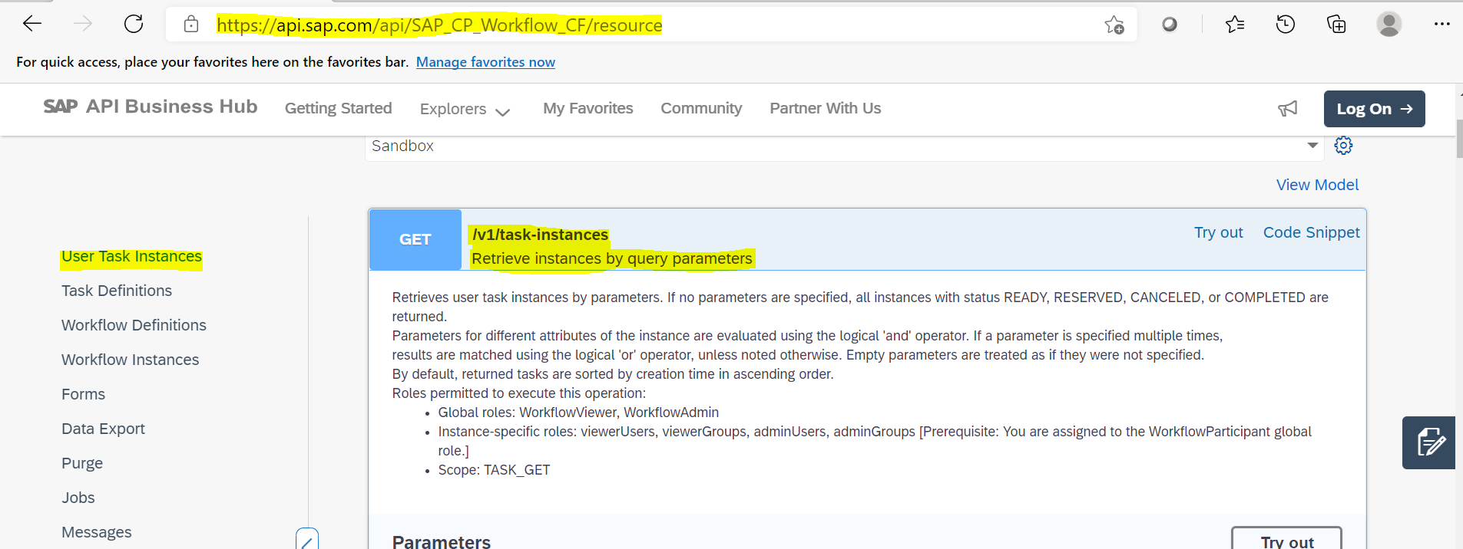

# Retrieve Workflow Context from Workflow Task

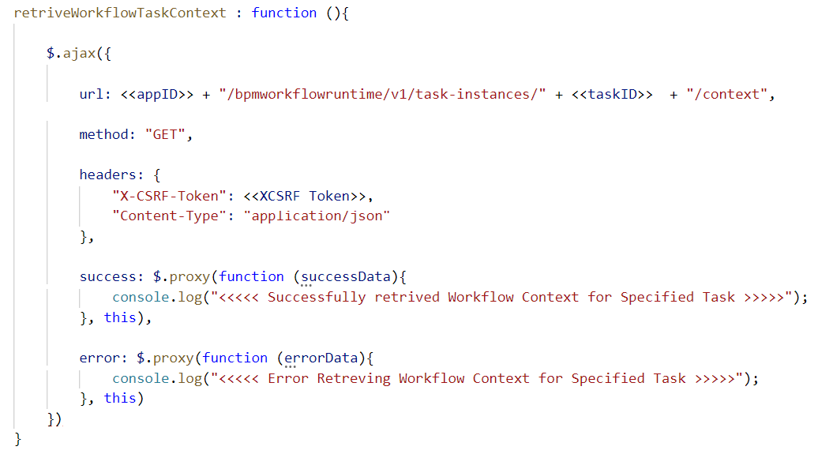

For <<appID>>, refer to section (Fetch Workflow XCSRF Token)

<<XCSRF Token>>: We can Get XCSRF Token, by executing code in section (Fetch Workflow XCSRF Token)

You can get <<taskID>> after executing code in section (Retrieve Workflow Task Instances)

For more information, please refer to below link

https://api.sap.com/api/SAP_CP_Workflow_CF/resource

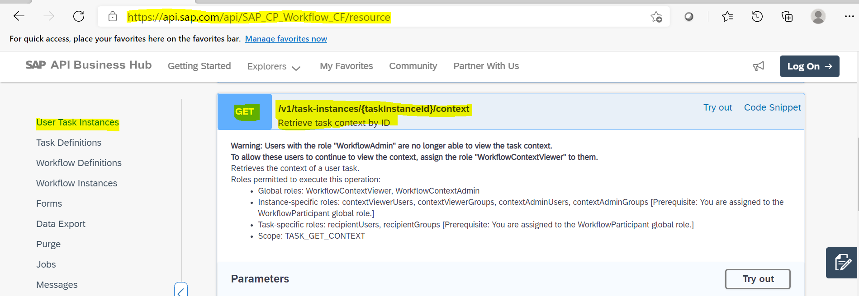

# Add Task Completions Buttons

In My Inbox, end users can complete task using Task Completion Buttons (Approve, Reject and etc)

In Component.js add the following code

